1. Download amazon_1 file from folder
2. Install putty and putty generator

<https://www.chiark.greenend.org.uk/~sgtatham/putty/latest.html>

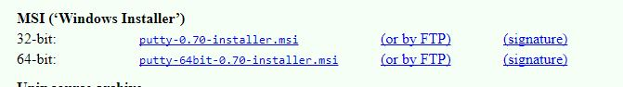

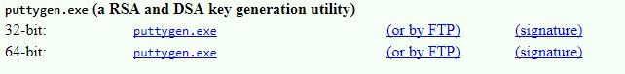

1. Open PuTTYgen

* Click **Load** the select and open amazon_1.pem
* Click **Save private key**
* Warning will be pop up

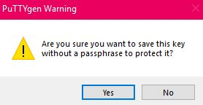

For now click on yes

* Then name the new file amazon_1 and save it the same place that your amazon_1.pem file is placed

1. Open the PuTTY

* On **Connection** section on side bar open **SSH** then open **Auth**
* Then Browse the Amazon_1 (PuTTY Private key File) on **Private key file for Authentication** box

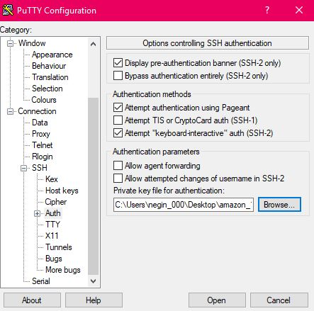

* The select **Session** on side bar
* Type “34.227.118.133” in **Host Name (or IP address)** box
* Type “amazon” in **Saved Session** box
* Click **Save**
* Then click **Load**

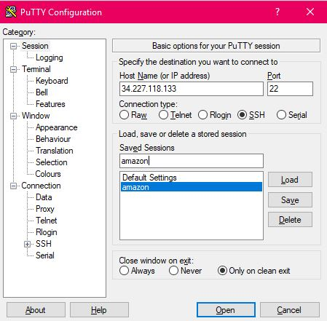

* PuTTY Security Alert will show up, click okey
* Then you type ec2-user in **Login as:** command line
* You are now connected to AWS server